Name: Trần Anh Tuấn
Student ID: 24521943
Class: CS4323.Q12.CTTT

OS
LAB 5

CHECKLIST
1. Homework
 | 1 | 2 | 3 | Bonus
Explanation
Your code
Results and discussions

Mark:

2. Lab 5
1. Implement the consume and produce
sells <= products <= sells + <4 last digit of SID>
Answer:
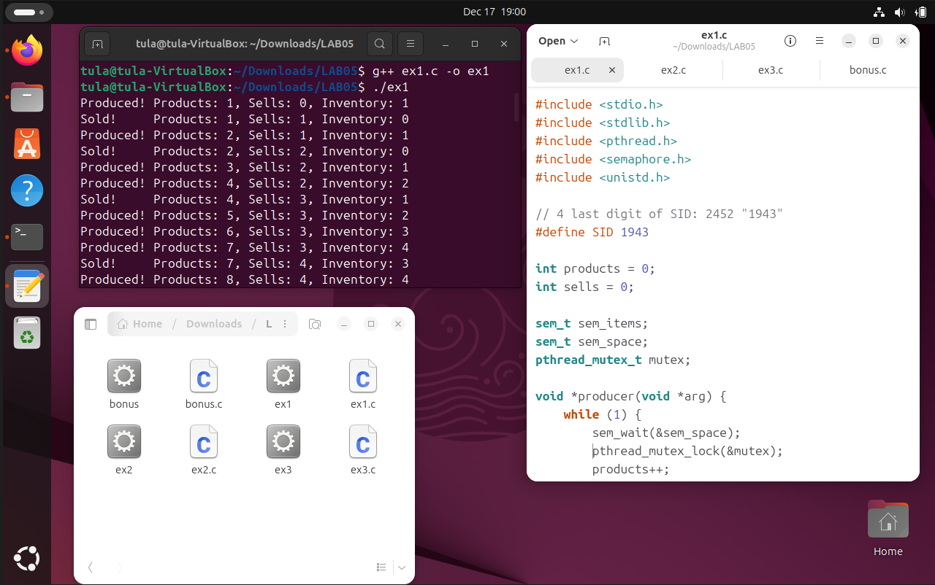
Code:
#include <stdio.h>
#include <stdlib.h>
#include <pthread.h>
#include <semaphore.h>
#include <unistd.h>

// 4 last digit of SID: 2452 "1943"
#define SID 1943

int products = 0;
int sells = 0;

sem_t sem_items;
sem_t sem_space;
pthread_mutex_t mutex;

void *producer(void *arg) {
while (1) {
sem_wait(&sem_space);
pthread_mutex_lock(&mutex);
products++;
printf("Produced! Products: %d, Sells: %d, Inventory: %d\n", products, sells, products - sells);
pthread_mutex_unlock(&mutex);
sem_post(&sem_items);

sleep(1);
}
}

void *consumer(void *arg) {
while (1) {
sem_wait(&sem_items);
pthread_mutex_lock(&mutex);
sells++;
printf("Sold! Products: %d, Sells: %d, Inventory: %d\n", products, sells, products - sells);
pthread_mutex_unlock(&mutex);
sem_post(&sem_space);

sleep(2);
}
}

int main() {
pthread_t t1, t2;

sem_init(&sem_items, 0, 0);
sem_init(&sem_space, 0, SID);
pthread_mutex_init(&mutex, NULL);

pthread_create(&t1, NULL, producer, NULL);
pthread_create(&t2, NULL, consumer, NULL);

pthread_join(t1, NULL);
pthread_join(t2, NULL);

sem_destroy(&sem_items);
sem_destroy(&sem_space);
pthread_mutex_destroy(&mutex);

return 0;
}
Explanation:
Logic:
- Semaphores: We use two semaphores to manage the buffer state.
  - sem_space: Tracks available empty slots in the warehouse. Initialized to MAX_BUFFER (2024). The Producer waits for this.
  - sem_items: Tracks actual products available for sale. Initialized to 0. The Consumer waits for this.
- Mutex: A mutex lock is used to protect the "Critical Section" (modifying the global variables products and sells) to prevent data inconsistency (race conditions).
Flow:
- Producer: Waits for sem_space -> Locks Mutex -> Increases products -> Unlocks Mutex -> Signals sem_items (increments item count).
- Consumer: Waits for sem_items -> Locks Mutex -> Increases sells -> Unlocks Mutex -> Signals sem_space (increments free space).

2. Given 4 threads T1, T2, T3, T4, whose jobs are print their name, running simultaneously. Let’s implement the process/thread synchronization for these 4 threads using the diagram beside.
Answer:
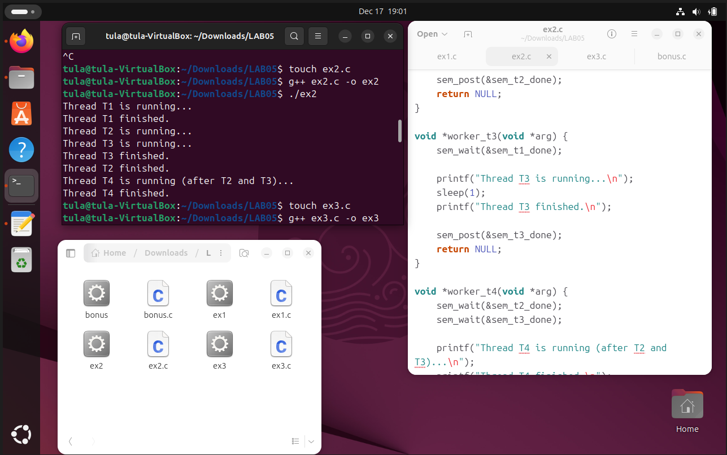
Code:
#include <stdio.h>
#include <pthread.h>
#include <semaphore.h>
#include <unistd.h>

sem_t sem_t1_done;
sem_t sem_t2_done;
sem_t sem_t3_done;

void *worker_t1(void *arg) {
printf("Thread T1 is running...\n");
sleep(1);
printf("Thread T1 finished.\n");

sem_post(&sem_t1_done);
sem_post(&sem_t1_done);

return NULL;
}

void *worker_t2(void *arg) {
sem_wait(&sem_t1_done);

printf("Thread T2 is running...\n");
sleep(1);
printf("Thread T2 finished.\n");

sem_post(&sem_t2_done);
return NULL;
}

void *worker_t3(void *arg) {
sem_wait(&sem_t1_done);

printf("Thread T3 is running...\n");
sleep(1);
printf("Thread T3 finished.\n");

sem_post(&sem_t3_done);
return NULL;
}

void *worker_t4(void *arg) {
sem_wait(&sem_t2_done);
sem_wait(&sem_t3_done);

printf("Thread T4 is running (after T2 and T3)...\n");
printf("Thread T4 finished.\n");

return NULL;
}

int main() {
pthread_t t1, t2, t3, t4;

sem_init(&sem_t1_done, 0, 0);
sem_init(&sem_t2_done, 0, 0);
sem_init(&sem_t3_done, 0, 0);

pthread_create(&t1, NULL, worker_t1, NULL);
pthread_create(&t2, NULL, worker_t2, NULL);
pthread_create(&t3, NULL, worker_t3, NULL);
pthread_create(&t4, NULL, worker_t4, NULL);

pthread_join(t1, NULL);
pthread_join(t2, NULL);
pthread_join(t3, NULL);
pthread_join(t4, NULL);

sem_destroy(&sem_t1_done);
sem_destroy(&sem_t2_done);
sem_destroy(&sem_t3_done);

return 0;
}
Explanation:
Logic:
- Dependencies:
  - T2 and T3 depend on T1.
  - T4 depends on both T2 and T3.
- Semaphores:
  - sem_t1_done: Signaled by T1. T2 and T3 wait for this before starting.
  - sem_t2_done & sem_t3_done: Signaled by T2 and T3 respectively upon completion.
Flow:
- T1 runs, finishes, and "posts" (signals) sem_t1_done twice to wake up both T2 and T3.
- T2 and T3 run in parallel. When finished, they signal their own completion semaphores.
- T4 calls sem_wait on both sem_t2_done and sem_t3_done. It will remain blocked until both T2 and T3 have finished.

3. Given an array a declared as an integer array with n elements, a is declared as a global variable. Write a program that includes 2 threads running concurrently:
Thread 1: performs the task of generating random integers, then adding them to array a. After adding, it counts and outputs the number of elements in a immediately after insertion
Thread 2: takes an element from array a (any element, depending on the implementation), then counts and outputs the number of elements in a immediately after removal. If there are no elements left in a, it should display “Nothing in array a”.
Answer:
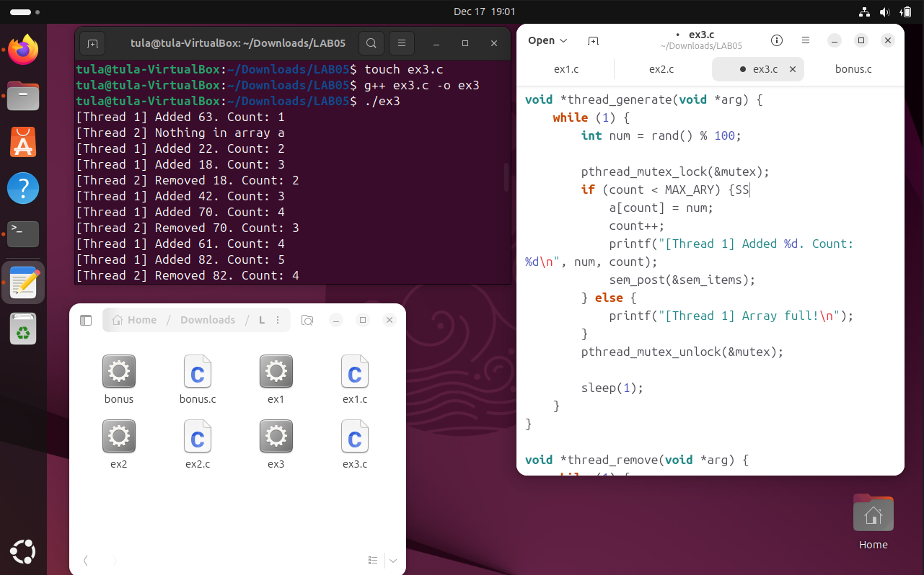
Code:
#include <stdio.h>
#include <stdlib.h>
#include <pthread.h>
#include <semaphore.h>
#include <unistd.h>
#include <time.h>

#define MAX_ARY 100

int a[MAX_ARY];
int count = 0;

pthread_mutex_t mutex;
sem_t sem_items;

void *thread_generate(void *arg) {
while (1) {
int num = rand() % 100;

pthread_mutex_lock(&mutex);
if (count < MAX_ARY) {SS
a[count] = num;
count++;
printf("[Thread 1] Added %d. Count: %d\n", num, count);
sem_post(&sem_items);
} else {
printf("[Thread 1] Array full!\n");
}
pthread_mutex_unlock(&mutex);

sleep(1);
}
}

void *thread_remove(void *arg) {
while (1) {
if (sem_trywait(&sem_items) == 0) {
pthread_mutex_lock(&mutex);
if (count > 0) {
int val = a[count - 1];
count--;
printf("[Thread 2] Removed %d. Count: %d\n", val, count);
}
pthread_mutex_unlock(&mutex);
} else {
printf("[Thread 2] Nothing in array a\n");
}

sleep(2);
}
}

int main() {
srand(time(NULL));

pthread_t t1, t2;

sem_init(&sem_items, 0, 0);
pthread_mutex_init(&mutex, NULL);

pthread_create(&t1, NULL, thread_generate, NULL);
pthread_create(&t2, NULL, thread_remove, NULL);

pthread_join(t1, NULL);
pthread_join(t2, NULL);

sem_destroy(&sem_items);
pthread_mutex_destroy(&mutex);

return 0;
}
Explanation:
Logic:
- The Challenge: Standard sem_wait() is "blocking," meaning if the semaphore is 0 (array empty), the thread sleeps indefinitely. The requirement is to print a message immediately if empty.
- The Solution (sem_trywait):
  - Thread 2 uses sem_trywait(&sem_items).
  - Case A (Array has data): The function returns 0 (success). The thread proceeds to lock the mutex and remove an element.
  - Case B (Array is empty): The function returns a non-zero error immediately (does not sleep). The else block executes, printing "Nothing in array a".
- Mutex: Ensures that when Thread 1 adds or Thread 2 removes an element, the array index (count) is updated safely.
Bonus.
You can calculate ans from x1, x2, x3, x4, x5, x6 where each variable may be calculated from below formulas:
w = x1 * x2; (a)
v = x3 * x4; (b)
y = v * x5; (c)
z = v * x6; (d)
y = w * y; (e)
z = w * z; (f)
ans = y + z; (g)
Assume the commands from (a) to (g) are in threads running concurrently. Write a program to simulate and synchronize these commands in C on the Linux operating system in the following order:
• (c), (d) can only be executed after x is calculated.
• (e) can only be executed after w and y are calculated.
• (g) can only be executed after y and z are calculated

Answer:

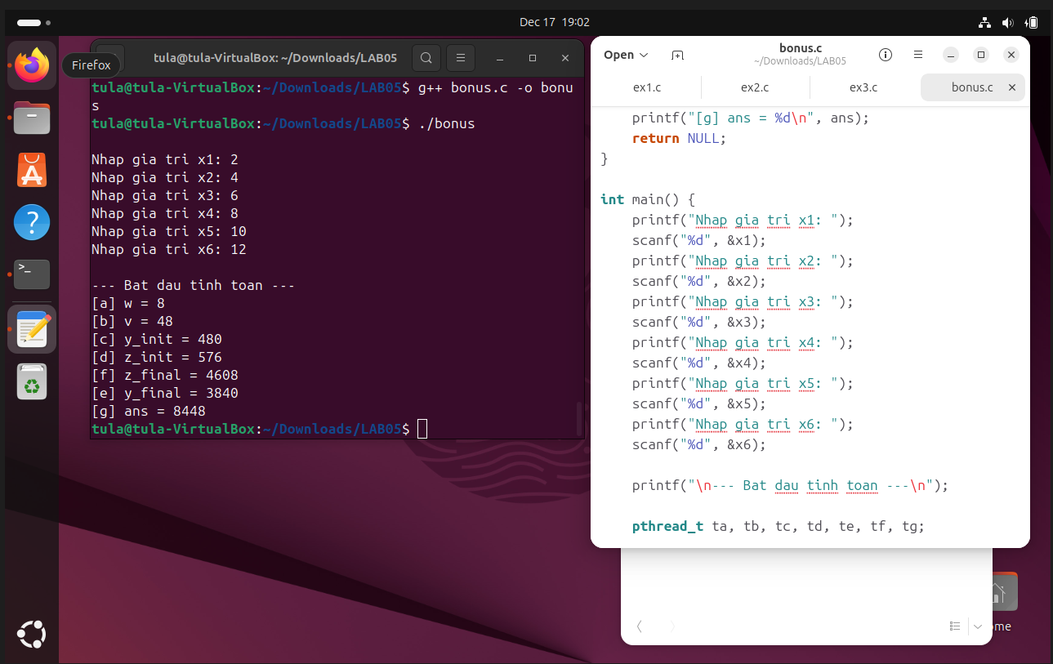
Code:
#include <stdio.h>
#include <stdlib.h>
#include <pthread.h>
#include <semaphore.h>
#include <unistd.h>

int x1, x2, x3, x4, x5, x6;
int w, v, y, z, ans;

sem_t sem_a_done;
sem_t sem_b_done;
sem_t sem_c_done;
sem_t sem_d_done;
sem_t sem_e_done;
sem_t sem_f_done;

void *calc_a(void *arg) {
w = x1 * x2;
printf("[a] w = %d\n", w);

sem_post(&sem_a_done);
sem_post(&sem_a_done);
return NULL;
}

void *calc_b(void *arg) {
v = x3 * x4;
printf("[b] v = %d\n", v);

sem_post(&sem_b_done);
sem_post(&sem_b_done);
return NULL;
}

void *calc_c(void *arg) {
sem_wait(&sem_b_done);

y = v * x5;
printf("[c] y_init = %d\n", y);

sem_post(&sem_c_done);
return NULL;
}

void *calc_d(void *arg) {
sem_wait(&sem_b_done);

z = v * x6;
printf("[d] z_init = %d\n", z);

sem_post(&sem_d_done);
return NULL;
}

void *calc_e(void *arg) {
sem_wait(&sem_a_done);
sem_wait(&sem_c_done);

y = w * y;
printf("[e] y_final = %d\n", y);

sem_post(&sem_e_done);
return NULL;
}

void *calc_f(void *arg) {
sem_wait(&sem_a_done);
sem_wait(&sem_d_done);

z = w * z;
printf("[f] z_final = %d\n", z);

sem_post(&sem_f_done);
return NULL;
}

void *calc_g(void *arg) {
sem_wait(&sem_e_done);
sem_wait(&sem_f_done);

ans = y + z;
printf("[g] ans = %d\n", ans);
return NULL;
}

int main() {
printf("Nhap gia tri x1: ");
scanf("%d", &x1);
printf("Nhap gia tri x2: ");
scanf("%d", &x2);
printf("Nhap gia tri x3: ");
scanf("%d", &x3);
printf("Nhap gia tri x4: ");
scanf("%d", &x4);
printf("Nhap gia tri x5: ");
scanf("%d", &x5);
printf("Nhap gia tri x6: ");
scanf("%d", &x6);

printf("\n--- Bat dau tinh toan ---\n");

pthread_t ta, tb, tc, td, te, tf, tg;

sem_init(&sem_a_done, 0, 0);
sem_init(&sem_b_done, 0, 0);
sem_init(&sem_c_done, 0, 0);
sem_init(&sem_d_done, 0, 0);
sem_init(&sem_e_done, 0, 0);
sem_init(&sem_f_done, 0, 0);

pthread_create(&ta, NULL, calc_a, NULL);
pthread_create(&tb, NULL, calc_b, NULL);
pthread_create(&tc, NULL, calc_c, NULL);
pthread_create(&td, NULL, calc_d, NULL);
pthread_create(&te, NULL, calc_e, NULL);
pthread_create(&tf, NULL, calc_f, NULL);
pthread_create(&tg, NULL, calc_g, NULL);

pthread_join(ta, NULL);
pthread_join(tb, NULL);
pthread_join(tc, NULL);
pthread_join(td, NULL);
pthread_join(te, NULL);
pthread_join(tf, NULL);
pthread_join(tg, NULL);

sem_destroy(&sem_a_done);
sem_destroy(&sem_b_done);
sem_destroy(&sem_c_done);
sem_destroy(&sem_d_done);
sem_destroy(&sem_e_done);
sem_destroy(&sem_f_done);

return 0;
}

